Kiwanis of Arroyo Grande Valley

Presents
2020
Scarecrow Contest

Decorate and display a scarecrow at your business in support of the 83th Annual Harvest Festival.
This year’s theme is
“Community Together”

Judging will take place during the week of September 21st. We hope to have a great big turnout of scarecrows all over Arroyo Grande. Make ‘em funny or artsy, original, fashion forward or creative. Make a scarecrow mascot for your business.

Display your scarecrow for the month of September leading up to the Harvest Festival, September 26 and 27.
Photos will be posted to the AG Harvest Festival Website.
- - - - - - - - - - - - - - - - - - - - - - - - - -
Scarecrow Entry Form
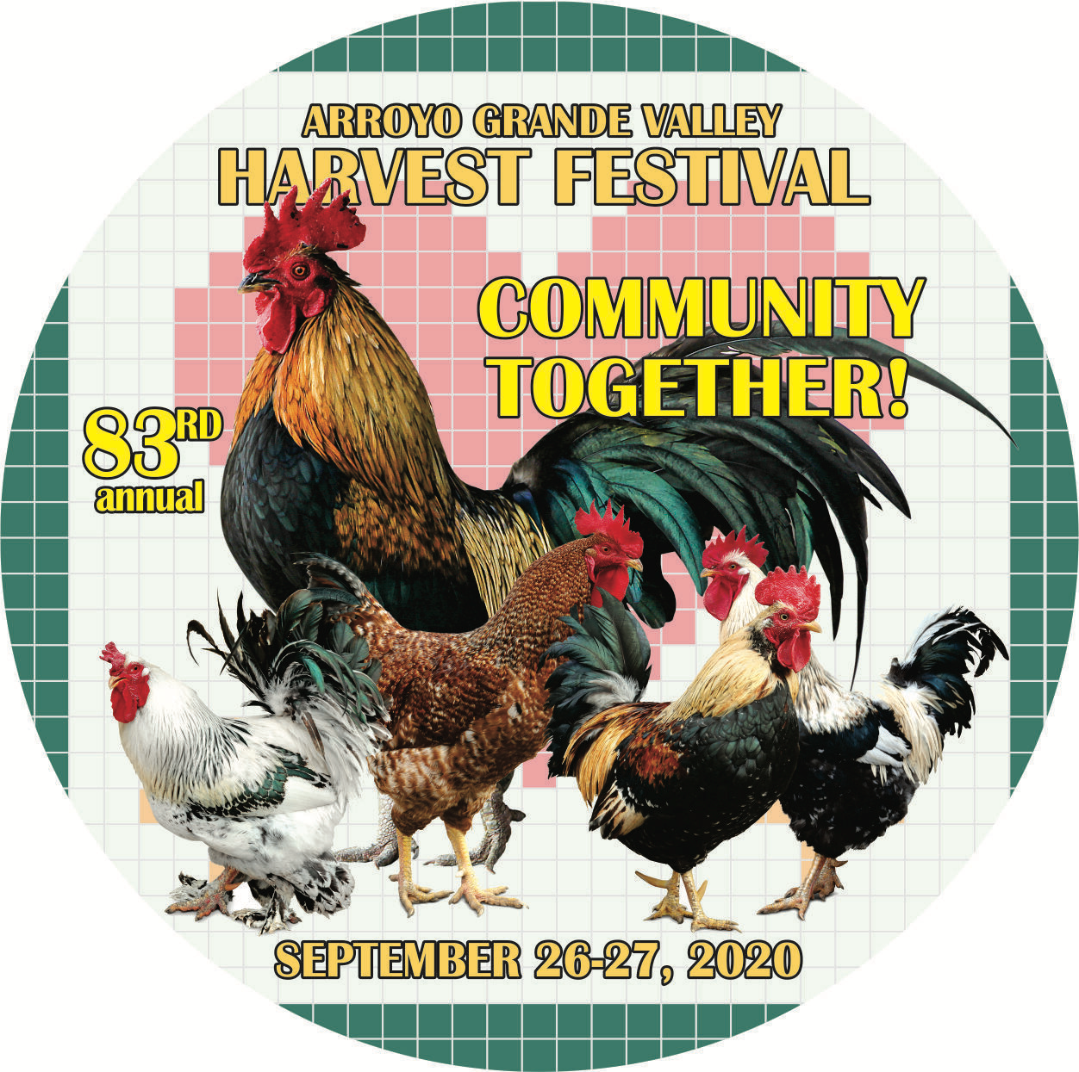
Business Name:______________________

Contact Name:______________________

Phone:______ Email:__________________

Address:_____________________________

Complete this form on-line at AGHarvestFestival@gmail.com
Or mail to AG Harvest Festival Scarecrows, PO Box 575, AG CA 93421
Questions? Call Maureen (805) 474-8560
Deadline to display: Saturday, September 5, 2020.
Judging will take place during the week of September 21nd. Winners will be announced at the Harvest Festival on September 26th during the introductory ceremonies.

